**HOME WORK No: 9**

|  |  |
| --- | --- |
| **NAME: CHANDA RICHARD CHIBWE**  **STUDENT ID: 201314010101**  **SCHOOL: INFORMATION & COMMUNICATION ENGINEERING**  **NATIONALITY: ZAMBIAN**  **COURSE: DIGITAL SIGNAL PROCESSING** |  |

**Task 9.8**

1. 

Since the maximum values of  and the minimum value = 0.

Hence and Therefore 

1. , 
2.  since 

and 

**Task 9.13**

1. Quantization of products before summing up

**The First cascade structure:**  The noise model of this structure is as shown below:

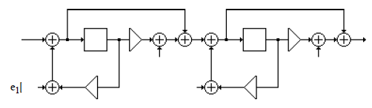

The noise transfer function from the noise source  to the filter output is:

 

The noise transfer function from the noise sources and  to the filter out is:



The normalized noise variance at the output due to each of these noise sources is:



The noise transfer function from the noise source  to the filter output is the corresponding normalized noise variance at the output is .

Therefore the total noise variance at the output is:

.

**The Second cascade structure:** .

The noise model of this structure is as shown below:

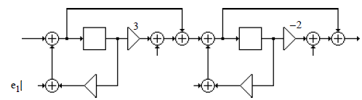

The noise transfer function from the noise source to the filter output is:



The corresponding normalized noise variance at the output is as below:



The noise transfer function from the noise sourcesand  to the filter output is as below:

 

The normalize noise variance at the output due to each of these noise sources is:



The noise transfer function from the noise source to the filter output is and the corresponding normalized noise variance at the output is Therefore the total noise variance at the output is: 

**The Third cascade structure:** 

The noise model of this structure is as below:

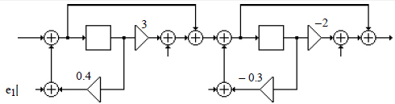

The noise transfer function form the noise sourceto the filter output is as below:



The corresponding normalized noise variance at the output is:



The noise transfer function from the noise sources  and  to the filter output is as below:



The normalized noise variance at the output due to each of these noise sources is as below:



The noise transfer function from the noise source is to the filter output is The corresponding normalized noise variance at the output is Therefore the total noise variance at the output is: 

**The Fouth cascade structure:** .

The noise model of this structure is as shown below:

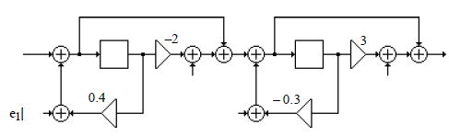

The noise transfer function from the noise source  to the filter output is



The corresponding normalized noise variance at the output is:



The noise transfer function from the noise sources  and  to the filter output is as below:

 The normalized noise variance at the output due to each of these noise sources is:  and the noise transfer function from the noise source  to the filter output is the corresponding normalized noise variance at the output is therefore the total noise variance at the output is: 

The Second cascade structure has the smallest roundoff noise variance.

1. **Quantization of products after addition**

From the results obtained in part (A), we have below the following roundoff noise variances:

1st cascade structure: 

2nd cascade structure: 

3rd cascade structure: 

4th cascade structure:

In case (B), we conclude that the 2nd cascade type has also the smallest roundoff noise variance.

**Task 9.14**

1. **Quantization of products before addiction**

First parallel form: 

The noise model is as below:

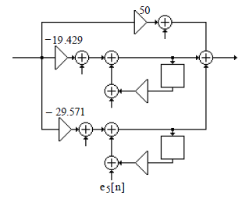

The noise transfer function from the noise source  to the filter output is  and its

corresponding normalized noise variance at the output is . The noise transfer function

from the noise sources  and  to the filter output is:

.

The normalized noise variance at the output due to each of these noise sources is:

.

The noise transfer function from the noise sources and to the filter output is:



The normalized noise variance at the output due to each of these noise sources is:



,

Therefore the total noise variance output is: .

Second parallel form: 

The noise model is as shown below:

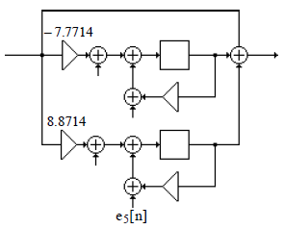

The noise transfer function from the noise sources and  to the filter output is:

. The normalized noise variance at the output due to each of these noise sources is: .

The noise transfer function from the noise sources and to the filter output is:

.

The normalized noise variance at the output due to each of these noise sources is: .

Hence the total noise variance at the output is: 

Therefore, the second Parallel form has the smaller roundoff noise variance.

1. **Quantization of products after addition**

First parallel form: From the results of part (A), we note that the total noise variance at the output is: and the Second parallel form is: .

**Task 9.15**



1. The noise model of the Direct Form 11 realization of  is as shown below:

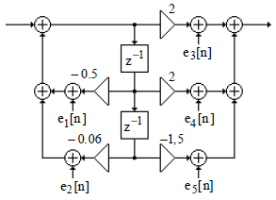

The noise transfer function from the noise sources, and  to the filter output is  and the noise transfer function from the noise sources and  to the filter output is as below:

,

Normalized noise variance at the output due to each of the noise sourcesandis then



The normalized noise variance at the output due to each of the noise sources, and is  Therefore the total noise variance at the output is

1. Cascade Form realization: .

There are more than two possible cascade realizations.

First Cascade Form:  and its noise model of realization is as shown below:

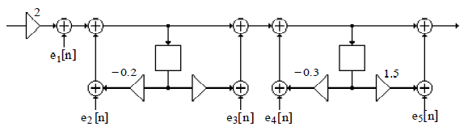

The noise transfer function from the noise sources  and  to the filter output is:

, and its output noise variance is as below:

.

The noise transfer function from the noise sources , and  to the filter output is:

, Its contribution to the output noise variance is

. Finally, the noise transfer function from the noise source to the filter output is  Its contribution to the output noise variance isTherefore the noise variance at the out the output is 